EMERCOM of Russia - Libya Floods Response
  - Storm Daniel, Derna, Libya — September 2023 – Author, Grigory Korolkov

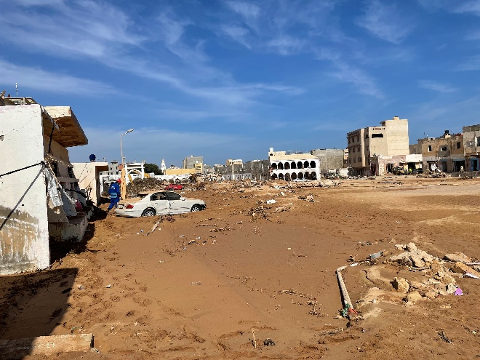
Introduction
- Between 9–11 September 2023, Storm Daniel caused catastrophic flooding across northeastern Libya.
- The collapse of the Mansour and Derna dams generated a devastating flood wave through Derna, causing widespread destruction, thousands of deaths and significant humanitarian needs.
- Following an international request for assistance, EMERCOM of Russia deployed its INSARAG-classified Heavy USAR Team (RUS-01), water rescue specialists and a mobile field hospital to support operations from 15–27 September 2023.

Objectives
- Conduct search and recovery operations in heavily affected areas of Derna.
- Support water-based search operations in coastal and port areas.
- Provide emergency medical assistance through a deployable field hospital.
- Coordinate with INSARAG, UNDAC and Libyan authorities to support a unified international response.

Response and Search & Rescue Operations
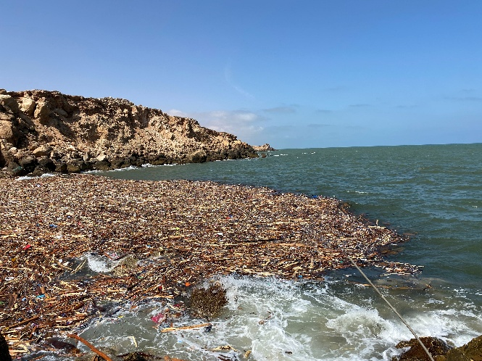
- EMERCOM mobilised 100 personnel, including 65 rescuers, two search dogs, water rescue teams, a mobile hospital, four trucks, one van and inflatable boats.
- Two IL-76 aircraft transported the team and equipment to Libya within hours of activation.
- The team established a Base of Operations in Derna and integrated into the INSARAG coordination structure through the Urban Search and Rescue Coordination Cell.
- Operational tasks included technical search, canine search, structural assessment, water-based recovery and support to maritime search activities.
- Close cooperation was maintained with international USAR teams from Hungary, Algeria, Türkiye and other responding organisations.

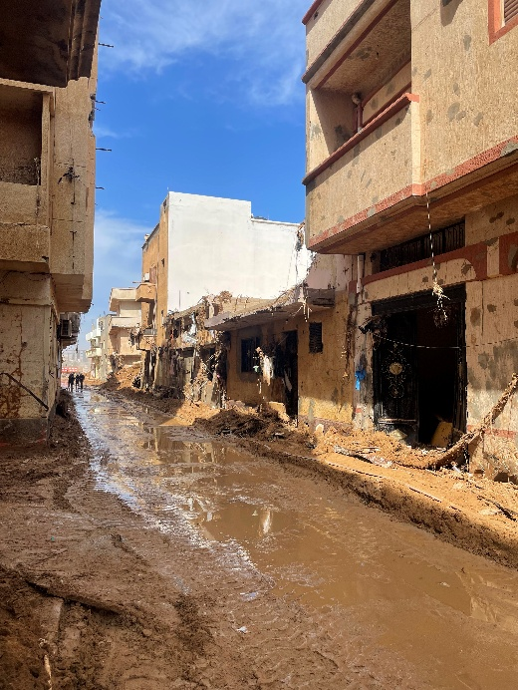
Outcomes
- 153 deceased victims were recovered, including 140 from the maritime environment.
- The mobile hospital treated 672 people, including 67 children.
- The water rescue team supported local authorities by producing a depth map of Derna port.
- The deployment demonstrated the value of integrating USAR, water rescue and medical capabilities into a single self-sufficient international response package.

Lessons Identified
- Rapid mobilisation and strategic lift: EMERCOM rapidly assembled personnel, equipment, vehicles and medical assets, supported by dedicated air transport and early stand-by arrangements.
- Multi-capability deployment: The combination of USAR, water rescue and field hospital capabilities provided a comprehensive response package suited to both rescue and humanitarian needs.
- Effective INSARAG coordination: Early integration with the UCC, attendance at Team Leader meetings and cooperation with international teams supported clear tasking and interoperability.
- Self-sufficiency: Communications, transport, accommodation, power and logistics systems allowed the team to operate without placing additional pressure on local resources.
- Transition from rescue to recovery: By the time most international teams arrived, the operating environment had largely shifted from rescue to recovery, reinforcing the need for scalable flood-specific planning frameworks.
- Water search and recovery doctrine: A significant proportion of operations occurred in maritime and flood-affected environments, highlighting the need for specialist flood, water rescue and recovery doctrine distinct from conventional earthquake USAR operations.
- Information management and situational awareness: Continuous monitoring of the Virtual OSOCC was valuable, but future operations would benefit from improved flood-specific common operating pictures, geospatial products and predictive modelling.
- Safety management: Unstable structures, contaminated water, debris fields and maritime hazards reinforced the importance of integrated structural, water and environmental safety management systems.
- Mixed-team interoperability: The response drew on USAR, flood rescue, marine rescue and professional diving capabilities from Libya, Algeria, Egypt, Italy, Tunisia, Türkiye and other partners, demonstrating the need for clear tasking, common terminology, compatible equipment and agreed coordination arrangements across mixed land, water and maritime rescue teams.
- ICMS in flood operations: The operation provided early experience using ICMS in a mixed emergency environment; however, near-zero internet connectivity, limited satellite reliability and the absence of flood-specific triage forms constrained its effectiveness, indicating the need for offline capability and integrated flood assessment tools.

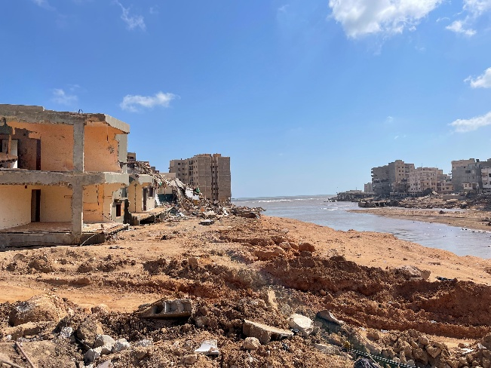
Recommendations
- Develop dedicated flood search and rescue guidance and operational methodologies within INSARAG.
- Enhance international water rescue and flood recovery capabilities within deployable teams.
- Strengthen the integration of medical, USAR and water rescue assets into a unified response model.
- Expand training and exercises focused on large-scale dam failures and urban flood disasters.
- Establish interoperability arrangements for mixed USAR, flood rescue, marine rescue, aviation and diving teams, including common tasking, safety controls, communications and escalation pathways for specialist access such as helicopter retrieval.
- Adapt ICMS for flood-related operations by developing offline functionality, low-bandwidth workflows and flood-specific triage and assessment forms to support field use where connectivity is degraded.
- Improve flood-specific information management, mapping and situational awareness tools to support decision-making.

Conclusion
- The EMERCOM deployment to Libya demonstrated the value of rapid international assistance, multi-capability response teams and strong INSARAG coordination mechanisms.
- The operation also reinforced the need for specialised flood response doctrine, enhanced water rescue capability and improved planning for large-scale flood disasters.
- The lessons identified from Derna provide important insights for strengthening future international flood search and rescue operations.
