Office for the Coordination of Humanitarian Affairs (OCHA)

Directory of International SAR Teams

Please return the updated questionnaire to the INSARAG Secretariat: insarag@un.org.

1. Team Information
1.1 | Team name: | MEDIUM USAR – ECU 01
 | Team name acronym (if exists): | ECU-01
 | Country: | Ecuador
 | Team type (delete non-applicable): | X [Governmental] [NGO] [Volunteers]
 | INSARAG External Classification (IEC): (indicate the details if classified) | [Classified] [Not Classified]
 | Year of last IEC (IER)
 | National Classification | Light  Medium X  Heavy
 | No classification
 | Year of Creation: | 2017
 | Recognition:
 | Website: | http://www.bomberosquito.gob.ec

2. Team Capacity according to INSARAG Guidelines
2.1 | Number of persons (can be a range e.g. 80-100): |  | 42
2.1 | INSARAG Guidelines trained |  | X Yes No
2.1 | Self sufficiency (tick applicable): |  | X Yes No
2.1 | Search component (tick applicable): |  | X Yes No
2.1 | Rescue component (tick applicable): |  | X Yes No
2.1 | Medical component (tick applicable): |  | X Yes No
2.1 | Trained according to INSARAG Guidelines (tick applicable): |  | X Yes No
2.1 | Capacity to strengthen an OSOCC or Reception Centre with liaison persons (tick applicable): |  | X Yes No

3. Contact Information:

National INSARAG Policy Focal Point (contact 1):
Name: | Jorge CARILLO TUTIVEN
Function: | Ministro
Organization: | Secretaria Nacional de Gestión de Riesgos
Address: | Edificio Centro Integrado de Seguridad km 0.5 vía Puntilla - Samborondon
Telephone: | +59342593500
e-mail: | secretario.riesgos@gestionderiesgos.gob.ec

National INSARAG Operations Focal Point (contact 2):
Name: | MASSAY Zaira
Function: | Operacional director
Organization: | Secretaria Nacional de Gestión de Riesgos
Address: | Edificio Centro Integrado de Seguridad km 0.5 vía Puntilla - Samborondon

Telephone:
e-mail: | director.operaciones@gestionderiesgos.gob.ec

USAR Team Focal Point (if different from above):
Name: | Gabriel Alejandro RODRIGUEZ RACINES
Function: | Capitán de Bomberos
Organization: | Cuerpo de Bomberos del Distrito Metropolitano de Quito
Address: | Veintimilla y Reina Victoria - Quito
Telephone: | +593 23 953 700 or +593 995 015 040

Fax:
e-mail: | grodriguez@bomberosquito.gob.ec

Please add additional contact persons below.

4. Team Structure:

Please provide information regarding the team structure.

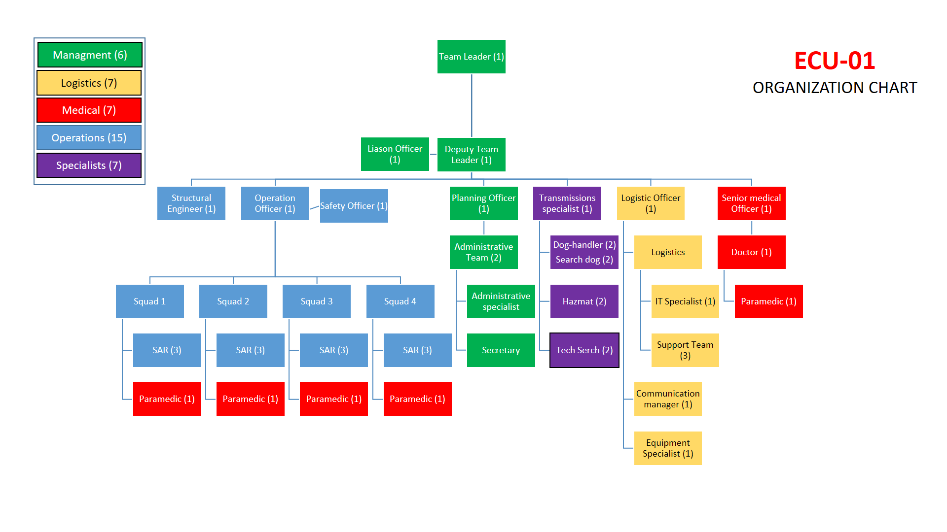

5. Operations:

Please list the international operations that the team responded.

Emergency (country, type, date)  (e.g. Turkey, earthquake – Aug 1999) | Number of Personnel | Duration of Deployment  (e.g. 7 days) | Comment  (e.g. 3 live rescues, setup of Sub-OSOCC, joint deployment with country x)
Eartquake Haiti | 15 | 12 | Search, victim extrication and stabilization, body recovery.
Eartquake Manabí | 50 | 10 | Search, victim extrication and stabilization, body recovery.
Eartquake Mexico | 19 | 8 | Technological Search y Shoring

-END-

