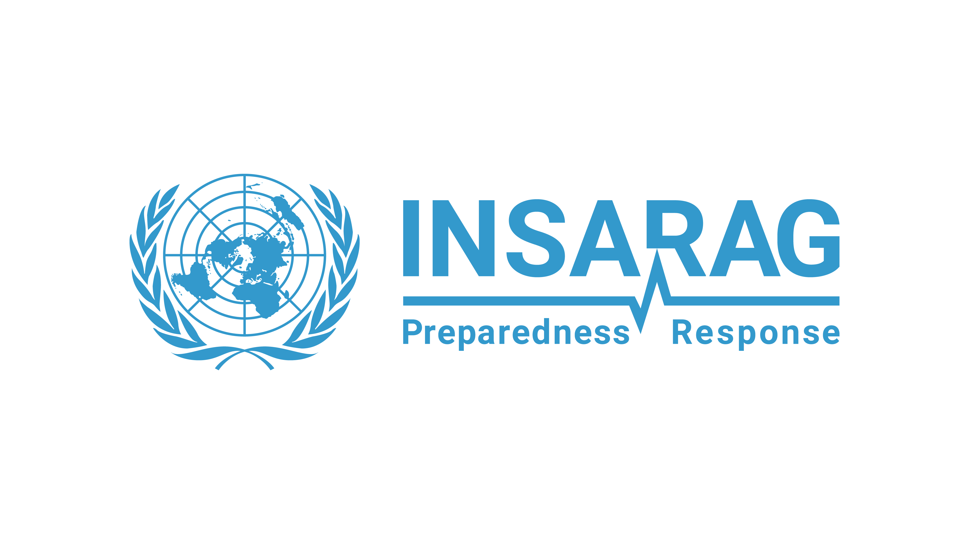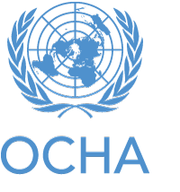

Draft INSARAG Strategic Plan 2026-2030

The Strategic Plan of the International Search and Rescue Advisory Group (INSARAG) presents the vision, mission, overarching goals and strategic objectives of the network, endorsed by the INSARAG Steering Group, for the period 2026-2030.

**Vision and Mission**

Our Vision is to save lives by promoting efficiency, enhanced quality and coordination amongst national and international Urban Search and Rescue (USAR) teams based on adherence to common guidelines and methodologies.

Our Mission is to prepare for, mobilize and coordinate effective, principled and flexible international USAR assistance in support of countries affected by collapsed structure emergencies, and to actively support capacity building at the international, regional, national and local level to ensure a localized and coherent response to emergencies.

**Mandate and Role**

INSARAG’s mandate is to strengthen the effectiveness and coordination of international urban search and rescue (USAR) efforts in disaster response, directly supporting the humanitarian imperative to save lives and alleviate suffering in sudden on-set disasters.

By fostering preparedness, interoperability, and rapid response capacity, INSARAG enables timely life-saving assistance in the aftermath of disasters, contributing to a more efficient and principled humanitarian action framework while also promoting international cooperation.

**Our role is to:**

* Develop and promote globally recognized standards for USAR assistance, coordination methodologies and tools.
* Mobilize and coordinate information exchange protocols between relevant stakeholders for rapid response.
* Promote cooperation and share experience with partners at local, national, regional and international levels with National Disaster Management Agencies from Member States, Non-Governmental Organizations (NGOs), the private sector, academia and other relevant networks.

**Values and Operational Norms**

* **Adherence to common standards and methodology:** Members of the INSARAG network commit to adhere to the INSARAG Guidelines and methodology as globally accepted and independently verifiable minimum operational standards and procedures, based on experts’ knowledge and evidence-based experience. The INSARAG network continues to develop these standards and procedures through shared and continuous learning.
* **Inclusiveness:** INSARAG brings together governments, governmental organizations, NGOs and disaster preparedness and response professionals. INSARAG particularly encourages disaster-prone countries to join the network, as well as any country or organization with USAR response capacity. INSARAG emphasizes the importance of gender awareness and considerations while working in disaster-affected areas.
* **Localization:** The INSARAG network contributes to ensuring that national and local capacities are empowered, context-specific knowledge valued and leveraged, and recognize that USAR first responders and communities are at the heart of effective and sustainable emergency response.
* **Gende**r: INSARAG is committed to promoting gender equality by ensuring equitable opportunities for participation in its events and activities. This includes striving for balanced representation within its governance structures—such as Regional Chairmanships and Working Groups—and the consistent use of gender-inclusive language.
* **Respect for Diversity:** INSARAG recognize, value, and actively embrace the differences among individuals and communities—across lines of culture, ethnicity, gender, age, disability, religion, nationality, and more.
* **Professionalism:** INSARAG promotes responsible, ethical and professional standards amongst USAR Teams and stakeholders.
* **Cultural sensitivity:** INSARAG promotes awareness and respect by international USAR Teams of cultural differences so that international USAR Teams can cooperate more effectively with national and international actors.
* **Needs-driven:** Mobilization and deployment of international USAR Teams is only supported when the affected country’s capacities are overwhelmed by the impact of a collapsed-structure emergency and national authorities request and/or agree to accept international assistance. Moreover, the type of international assistance rendered is based on the needs of the affected country and not driven by the availability of resources.
* **Coordination:** INSARAG promotes internationally agreed coordination structures managed and advocated by the United Nations Office for the Coordination of Humanitarian Affairs (OCHA), promotes coordination of preparedness and capacity building activities, and, throughout an operation, assists Member States and affected countries in coordinating the emergency response.
* **Predictability:** INSARAG’s operational predictability is anchored in the deployment of Classified Teams that adhere to recognized international standards, apply harmonized guidelines and procedures, and utilize common coordination platforms — both in the field and virtually

All members of the INSARAG community, led by the Global and Regional Chairs, supported by the Working Groups and the INSARAG Secretary in OCHA, will work to encourage the sustainability, relevance and cost-effectiveness of INSARAG’s activities.

**Strategic Objectives**

Our Strategic Objectives for 2026-2030, developed by the INSARAG network, feed into a global framework which informs the INSARAG Regional Groups’ strategies and objectives and guides their implementation. In a time marked by the humanitarian reset, the Strategic Objectives 2026-2030 must remain adaptable in order to navigate , adapt and evolve to the impacts of a changing humanitarian landscape.

**Strategic Objective 1: Quality Standards**

Advance and uphold globally recognized quality standards for Urban Search and Rescue (USAR) operations to ensure effective, professional, and coordinated emergency response.

**Key Actions**

* 1. Continuously review and enhance INSARAG Guidelines to remain fit for purpose and aligned with evolving global needs.
  2. Promote and encourage USAR teams mandated for international deployments to participate in the INSARAG External Classification (IEC) and Reclassification (IER) processes to enhance efficiency in emergency response.
  3. Ensure that the network has the capacity to uphold the established model for quality assurance and classification in a sustainable way, even as the network grows and the conditions change.
  4. Promote the adoption and localization of INSARAG coordination methodology and concepts to country contexts.

**Strategic Objective 2: Flexible Response**

Promote agility and flexibility of rescue teams in response operations across other disaster relief activities, given the increase in extreme weather-related disasters requiring assistance beyond conventional USAR operations, to ensure future sustainability of USAR assets at national and international level and to stay relevant to the needs of the affected people.

**Key Action:**

2.1 Continue to develop flexible operational models beyond traditional USAR response, such as the Flood Response capabilities and directories.

2.2 Support the development of flexible approaches that enable USAR teams to operate effectively in diverse and challenging contexts, such as during pandemics, in areas without internet or established UCC, ensuring readiness and relevance in an evolving operational environment

2.3 Strengthen flood response capacities for the network through knowledge sharing and capacity building

**Strategic Objective 3: Strengthening Localization**

Strengthen the INSARAG network by empowering regional, national, and local actors through inclusive engagement, knowledge exchange, and decision-making that reflects local realities and regional priorities. Enhance emergency response coordination and effectiveness by fostering inclusiveness, sustaining long-term partnerships, and expanding collaborative efforts rooted in local leadership.

**Key Actions:**

3.1 Establish and support tailored regional groups to ensure that INSARAG’s approaches, tools, and coordination mechanisms are adapted to regional languages, cultures, and operational contexts.

3.2 Support the implementation of national accreditation systems through the INSARAG Recognized National Accreditation Process (IRNAP) and promote the INSARAG First Responders Training Package to enhance community-level preparedness.

**Strategic objective 4: Bolstering Partnerships and Technological advancements**

INSARAG is committed to continuously enhancing its disaster response capabilities by fostering strong partnerships and embracing innovative technologies, tools, and methodologies. As the nature of emergencies evolves, so must the collaborative and technological approaches used to address them. Through open exchange, joint innovation, and the thoughtful integration of advancements, INSARAG aims to strengthen the agility, effectiveness, and global relevance of its network.

**Key Actions**

4.1 Deepen collaboration with existing partners (e.g., IFRC, UNDAC, EMTs, regional organizations) and establish new technical and operational partnerships with local authorities, NGOs, private sector actors, and academic institutions to enhance collective preparedness and response.

4.2 Explore and pursue diverse and innovative funding mechanisms to ensure sustainable support for expanding activities, including partnerships with non-traditional donors and alternative resource mobilization strategies. Particular emphasis will be placed on supporting training and capacity-building initiatives in developing countries, thereby reinforcing the localisation of response efforts and promoting inclusivity in line with INSARAG’s core values.

4.3 Encourage Working Groups and USAR teams to identify, test, and share insights on new technologies and approaches that enhance operational readiness and response.

**Strategic objective 5: USAR Access and Safety in Complex Emergencies**

Explore INSARAG’s role and capacity to support life-saving response in complex emergencies, including disaster situations in conflict-affected or politically sensitive areas, while upholding humanitarian principles and ensuring responder safety.

**Key Actions**

5.1 Explore and assess what role the INSARAG network and USAR Operations can play in complex emergencies.

5.2 Develop standard operating procedures (SOPs) to guide the decision-making processes prior to INSARAG network alert and deployment for USAR operations in complex emergency settings.