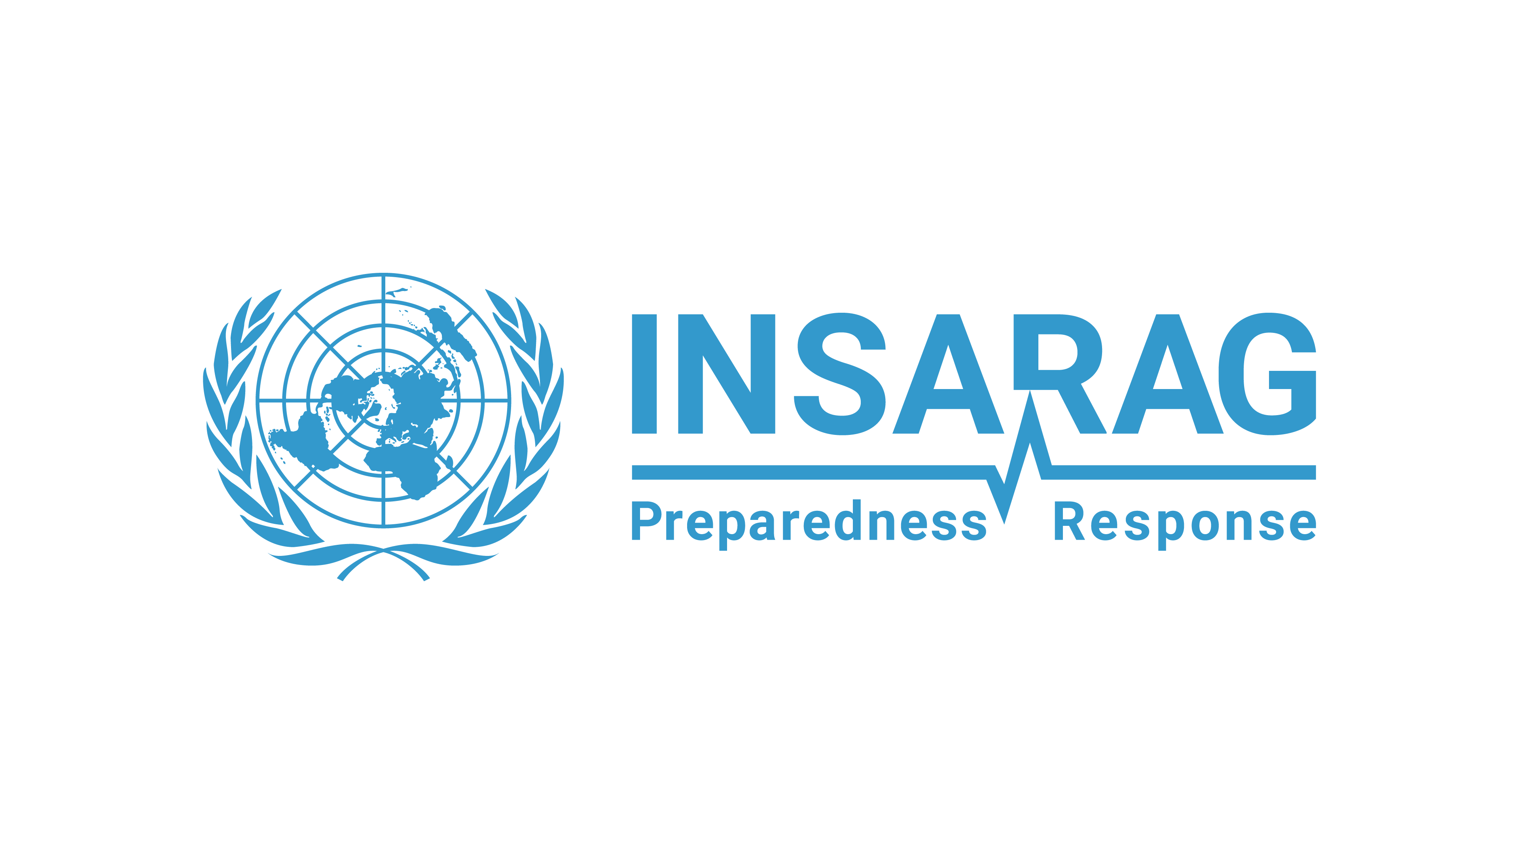
Draft INSARAG Calendar 2025
Month | Event | Start Date | End Date | Event Name | Event type | Country | Location
JAN | 1 | 13-Jan-25 | 17-Jan-25 | INSARAG Leadership Course | Training | Qatar | Doha
 | 2 | 16-Jan-25 | 16-Jan-25 | INSARAG New Year Teleconference | Meeting | Switzerland | Bern
 | 3 | 27-Jan-25 | 31-Jan-25 | Netherlands (NED-01) - Heavy (EU MODEX) (1/12 IER) | IER | Portugal | Lisbon
FEB | 4 | 09-Feb-25 | 14-Feb-25 | Team Leaders Meeting and Working Groups Meetings (09-11 WG and 12-14 TL) | Meeting | Tunisia | Tunis
MAR | 5 | 17-Mar-25 | 28-Mar-25 | HNPW 2025 (Face-to-face week at the CICG is 24-28 of March) | Meeting | Switzerland | Geneva
 | 6 | 24-Mar-25 | 24-Mar-25 | INSARAG AP informal meeting (during HNPW) | Meeting | Switzerland | Geneva
 | 7 | 25-Mar-25 | 25-Mar-25 | INSARAG Steering Group (ISG) | Meeting | Switzerland | Geneva
 | 8 | 26-Mar-25 | 26-Mar-25 | Quality Standards for Effective Response, Saving Lives: INSARAG & WHO EMT | Meeting | Switzerland | Geneva
 | 9 | 31-Mar-25 | 4-Apr-25 | France (FRA-02) - Heavy (2/12 IER) | IER | France | Sancoins
 | 10 | 7-Apr-25 | 11-Apr-25 | ICMS Course | Training | Moscow | Russian Federation
APR | 11 | 14-Apr-25 | 16-Apr-25 | Poland (POL-01) - Heavy (3/12 IER) | IER | Poland | Gdańsk
 | 12 | 28-Apr-25 | 2-May-25 | IRNAP Course | Training | Canada | TBC
MAY | 13 | 24-May-25 | 30-May-25 | China (CHN-01) - Heavy (4/12 IER) | IER | China | Beijing
 | 14 | 24-May-25 | 30-May-25 | China (CHN-02) - Heavy (5/12 IER) | IER | China | Beijing
AUG | 15 | 7-Aug-25 | 8-Aug-25 | AP Regional Meeting | Meeting | Japan | Tokyo
 | 16 | 11-Aug-25 | 15-Aug-25 | Belarus (BLR-01) - Heavy (6/12 IER) | IER | Belarus | Minsk & Borisov
 | 17 | 18-Aug-25 | 21-Aug-25 | Singapore (SGP-01) - Heavy (7/12 IER) | IER | Singapore | Singapore City
SEP | 18 | 2-Sep-25 | 6-Sep-25 | Ukraine (UKR-01) - Heavy (8/12 IER) | IER | Poland | Gdańsk
 | 19 | 8-Sep-25 | 12-Sep-25 | Australia (AUS-01) - Heavy (9/12 IER) | IER | Australia | Brisbane
 | 20 | 2-Oct-25 | 5-Oct-25 | Working Group Meeting | Meeting | Czech Republic | Prague
OCT | 21 | 6-Oct-25 | 7-Oct-25 | AEME Regional meeting | Meeting | Czech Republic | Prague
 | 22 | 13-Oct-25 | 17-Oct-25 | Türkiye (TUR-02) - Heavy (10/12 IER) | IER | Türkiye | Ankara
 | 23 | 19-Oct-25 | 23-Oct-25 | Jordan (JOR-01) - Heavy (11/12 IER) | IER | Jordan | Amman
 | 24 | TBC | TBC | AP International Earthquake Response Exercise (IERE) | Exercise | TBC | TBC
NOV | 25 | 4-Nov-25 | 8-Nov-25 | Georgia (GEO-01) - Light (1/3 IEC) | IEC | Georgia | Tbilisi
 | 26 | 10-Nov-25 | 14-Nov-25 | Thailand (THA-10) - Medium (2/3 IEC) | IEC | Thailand | Chai Nat
 | 27 | 17-Nov-25 | 21-Nov-25 | Türkiye (TUR-01) - Heavy (12/12 IER) | IER | Türkiye | Istanbul
 | 28 | 25-Nov-25 | 29-Nov-25 | Americas International Earthquake Response Exercise (IERE) | Exercise | TBC | TBC
 | 29 | TBC | TBC | AEME International Earthquake Response Exercise (IERE) | Exercise | South Africa | TBC
DEC | 30 | 1-Dec-2025 | 4-Dec-2025 | China IRNAP in Beijing | IRNAP | China | Beijing
 | 31 | TBC | TBC | Americas Regional Meeting | Meeting | TBC | TBC
 | 32 | 07-Dec-25 | 11-Dec-25 | Oman (OMA-01) - IEC Medium > Heavy (3/3 IEC) | IEC | Oman | Muscat

