**INSARAG Guidelines Review Group**

**Marmaris, Türkiye**

**08:30 – 17:00**

**Attendees:** GRG Co-Chairs**:** Martin Evers (Netherlands) and John Cawcutt (Australia),   
**AEME**: Martin Pavek (Czech Republic), Emmanuel Chapeau (France), Yvonne R. Gutmann (Germany), Fahad Sultan (Qatar), Belit Tasdemir (Türkiye NGO), Ove Syslak (Norway), **Americas**: Sara Rathbun (USA), Patricio Fuentes (Chile); **AP:** --- **.**

**Secretariat Representative:** Lucien Jaggi

**Absent:** Li Li (China), Safrizan Bin Suhaini (Malaysia), Wee Keong (Singapore), Ciro Bolognese (Italy).

1. **OPENING and AGENDA by the CO-CHAIRS**

* The Co-Chairs welcome the GRG members and INSARAG Secretariat to the meeting
* The GRG thanked AKUT (TUR-03) for facilitating this meeting
* On the agenda of this meeting were:
  + summary of concluded work
  + reconciliation with tasked items by INSARAG
  + establishment of work packages for open items
  + updating GRG timeline and further proceeding
  + preparing input for Regional Meetings 2024

1. **GRG ITEMS AND CURRENT STATE OF AFFAIRS**

The following tables list all items the GRG reviewed, giving a summary and an update on their current status.

*Full text can be found in the INSARAG Governance Review 2024, Annex G.*

|  |  |  |
| --- | --- | --- |
| **RECOMMEN- DATION No.** | **SUMMARY** | **STATUS** |
| 1-2 | Localisation | awaiting outcome of Regional Meetings 2024 |
| 3 | Complex Emergencies | Parking Lot – ERS to review |
| 4 | Climate Change |
| 5 | Inclusion of humanitarian principles and definition | completed |
| 6 | Review the Core Humanitarian Standard by INSARAG network organisations | Parking Lot – ERS to review |
| 7 | Consider application of GA Res. 78/119 in USAR work | no action by GRG |
| 8 | Leadership & Governance | awaiting outcome of Regional Meetings 2024 |
| 9 | Global Strategy 2025-2030 | Secretariat |
| 10 | Quarterly inductions by RFPs for new PFP, OFP, TWP, WG-Chairs and Regional Chairs | awaiting outcome of ISG 2025 |
| 11 | Responsibility for decisions of participation for classified NGO teams | awaiting outcome of ISG 2025 |
| 12 | Updating PFP ToR | Parking Lot – ERS to review |
| 13 | Change to gendered language within ToR | in process (by GRG) |
| 14 | Including mandatory attendance at induction session for new focal points | Parking Lot – ERS to review |
| 15 | Implementing a yearly meeting between PFPs, OPFs and TFPs | in process (by GRG) |
| 16 | Drafting ToR for Team Leader & Team Focal Point | Secretariat |
| 17 | Prioritisation recruitment of vacant positions | Parking Lot – ERS to review |
| 18 | Global Meeting | awaiting outcome of Regional Meetings 2024 |
| 19 | Drafting ToR for for Incoming/Outgoing Regional Vice Chair | Parking Lot – ERS to review |
| 20 | Planning Troika 5 years ahead | awaiting outcome of ISG 2025 |
| 21 | Drafting ToR for Regional Focal Point | Secretariat |
| 22 | Creation of Regional Committees | Parking Lot – ERS to review |
| 23 | Creation of Regional Operational Meetings |
| 24 | Creation of Regional Steering Group |
| 25 | No formal split of the regions | Parking Lot – ERS to review |
| 26 | Adding additional Regional Focal Point (RFP) to Secretariat. | Parking Lot – ERS to review |
| 27 | Considering staffing through regions | Parking Lot – ERS to review |
| 28 | Update ToRs for PFPs and OFPs with emphasise on better communication | Parking Lot – ERS to review |
| 29 | Update ToRs for OFPs and TFPs with emphasise on better communication |
| 30 | Team Leaders Meetings to be held in a hybrid format | awaiting outcome of Team Leaders Meeting 2025 |
| 31 | The Global Meeting to be discontinued; topics are addressed at the Team Leaders | awaiting outcome of Regional Meetings 2024 & ISG 2025 |
| 32 | Training for TFPs, Classifiers and Mentors at Team Leaders Meetings | to be discussed with TWG |
| 33 | Multi-language, online training for Team Leaders, Classifiers and Mentors | referred to TWG |
| 34 | Converting selected trainings held in presence to online trainings |
| 35 | Securing skillset and requirements for nominated Working Group Members are met. | awaiting outcome of Regional Meetings 2024 & ISG 2025 |
| 36 | Ensuring that proposed Working Group Members have the role enshrined in their day-to-day activities. | awaiting outcome of Regional Meetings 2024 & ISG 2025  GRG to add to TOR of Working Groups |
| 37 | Creating observer status in Working Groups. | awaiting outcome of Regional Meetings 2024 & ISG 2025 |
| 38 | Ensuring balanced representation whithin of Co-Chairs | awaiting outcome of Regional Meetings 2024 & ISG 2025 |
| 39 | Limiting the number of Working Groups to the number of RFPs, to ensure adequate support. | awaiting outcome of Regional Meetings 2024 & ISG 2025 |
| 40 | Change letter of endorsement by PFP with letter of acknowledgement for NGOs aiming for Classification. | awaiting outcome of Regional Meetings 2024 & ISG 2025 |
| 41 | Correspondence between NGOs and INSARAG Secretariat do not go through national focal points |
| 42 | NGO TL / focal points can represent their region within the Regional Operational Meetings |
| 43 | Accountability & Compliance |
| 44 | Inclusion of internal investigations framework within INSARAG Guidelines |
| 45 | Discussing implementation of soft and hard penalites |
| 46 | Decision-Making Mandate & Responsibilities |
| 47 | Amend the wording within section 2.6 to  place the focus on building domestic/national capacity first |
| 48 | Geographic, Diversity and Representation | awaiting outcome of Regional Meetings 2024 & ISG 2025 |
| 49 | Strengthening women or non-binary/ transgender representation within the INSARAG network |
| 50 | Implementing positive discrimination policies in favour of achieving a greater gender balance within USAR teams. |
| 51 | Integration of UN Resolution A/RES/78/119 | completed |
| 52 | Provide a balance of face-to-face and online meetings; investment of safed funds to facilitate online meetings | ERS |

*Full text can be found in the After Action Analysis and Recommendations for INSARAG Türkiye 2023.*

|  |  |  |
| --- | --- | --- |
| **Chapter** | **SUMMARY** | **STATUS** |
| 3.1.1 | Speed of mission activation | paragraph drafted; under review |
| 3.1.2 | Flexibility / Adaptability and ASR level | referred to TWG;  GRG awaiting info |
| 3.1.3 | Building Marking | referred to IMWG;  GRG awaiting info |
| 3.1.4 | Triage and survivability in voids | referred to TWG;  GRG awaiting info |
| 3.1.5 | New roles and strengthening roles | awaiting outcome of Regional Meetings 2024 |
| 3.3.1 | Connections with LEMA at every level | To be completed |
| 3.3.2 | UCC and LEMA connection | referred to TWG;  GRG awaiting info |
| 3.3.3 | Working with LEMA |
| 3.3.4 | Managing expectations of LEMA support | To be completed Volume 1 and 2 GRG |
| 3.3.5 | Declaring End of International USAR operations | awaiting outcome of Regional Meetings 2024 |
| 3.3.6 | Donation process | ERS, TWG |
| 3.3.7 | Beyond the rubble | To be completed, TWG |
| 3.3.8 | Training of LEMA here: drafting template on request of assistance | drafted by GRG (completed); referred to NCBWG for review & finalisation |
| 3.7 | Safety and Security issues | referred to TWG;  GRG awaiting info |
| 3.8 | Team responsibility  here: drafting document regarding asbestos | drafted by MWG (completed); referred to GRG for review |
| 3.10.1 | Compliance | referred to IEC/R WG;  GRG awaiting info |
| 3.10.2 | IEC/R | referred to IEC/R WG;  GRG awaiting info |

*Further items*

|  |  |  |
| --- | --- | --- |
| **ORIGIN** | **SUMMARY** | **STATUS** |
| ISG 2020 | Include Warsaw Declaration | completed |
| Flexibility in response operations | in process (by GRG) |
| ERE review | no further action by GRG |
| ISG 2022 | Hierarchy of Guidelines, Guidance Notes & Technical Reference Library | in process / completed |
| Guidance Note for non-USAR teams | in process (by GRG) |
| IRNAP Technical Guidance Note | referred to NCBWG |
| UC Manual V2.0 | TWG |
| Community Responder Training | completed by GRG;  referred to NCBWG for review and further development |
| Inclusion of Heritage Site Guideline | in process (by GRG) |
| ISG 2023 | Review decision-making process | see items from *Governance Review 2024* |
| GRG 2023 | VOSOCC / ICMS duplications | referred to IMWG/TWG |
| Deconflicting Team Fact Sheets |
| UCC sectorisation and ASR 1 |
| one-pager on ICMS for unclassified teams | referred to IMWG |
| minimum level UCC/SCC | referred to TWG |
| INSARAG patch with year of first classification | completed |
| IEC/R for capacity change downwards | in process IER/IEC WG |
| Completed Worksite definition | referred to TWG |
| Clarification on ASR 2 phase when interrupted by “blitz mode” |
| Review management of priorisation / triage of category C |
| Include probability assessment of survival |
| ASR 2: Clarification assessment and action tactic/strategy |
| Review of workside ID system | referred to IMWG |
| Draft on-page regarding INSARAG / ICMS for non-classified teams | in process (by GRG) |
| Clarification on UCC/SCC minimum level for teams completing IRNAP/NAP | referred to TWG and NCBWG |
| Change of Classification-patch from last classification to “classified since” | in process (by GRG) |
| Discussion of IEC or IER for downwards change in capacity (heavy to medium) | referred to IEC/R WG |
| GRG online update on INSARAG.org | completed |

1. 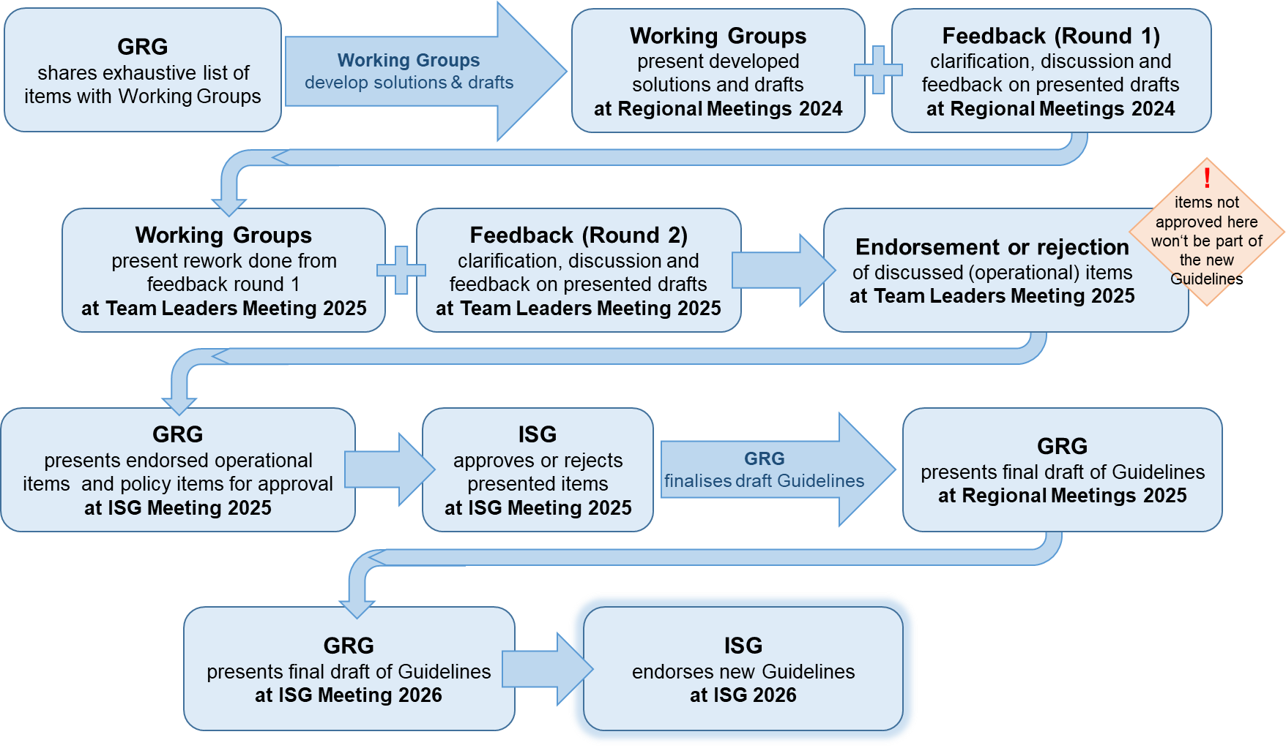**TIMELINE FOR THE GRG 2023-2025**

Clarification: The GRG has the mandate to review the Guidelines 2020 and can facilitate changes in strucuture and phrasing on their own. For modifications in content, the mandate to propose changes lies with the Working Groups. operational items need to be endorsed by the Team Leader (at Team Leaders Meetings). The final approval of content changes can only be given by and through the ISG. **For the release of the Guidelines in 2026, all items to be included have to be approved at the ISG 2025.**

1. **ISSUES TO BE ADDRESSED AND PRIORITIES**

Following items from tables under point 2 need to be raised at the Regional Meetings 2024:

|  |  |
| --- | --- |
| **ORIGIN**: *INSARAG Governance Review 2024* | |
| 1-2 | Localisation |
| 8 | Leadership & Governance |
| 9 | Global Strategy 2025-2030 |
| 18 | Global Meeting |
| 19 | Drafting ToR for for Incoming/Outgoing Regional Vice Chair |
| 20 | Planning Troika 5 years ahead |
| 26 | Adding additional Regional Focal Point (RFP) to Secretariat |
| 27 | Considering staffing through regions |
| 30 | Team Leaders Meetings to be held in a hybrid format |
| 31 | The Global Meeting to be discontinued; topics are addressed at the Team Leaders. |
| 37 | Creating observer status in Working Groups. |
| 40 | Change letter of endorsement by PFP with letter of acknowledgement for NGOs aiming for Classification. |
| 41 | Correspondence between NGOs and INSARAG Secretariat do not go through national focal points |
| 42 | NGO TL / focal points can represent their region within the Regional Operational Meetings |
| 43 | Accountability & Compliance |
| 44 | Inclusion of internal investigations framework within INSARAG Guidelines |
| 45 | Discussing implementation of soft and hard penalites |
| 46 | Decision-Making Mandate & Responsibilities |
| 47 | Amend the wording within section 2.6 to  place the focus on building domestic/national capacity first |
| 48 | Geographic, Diversity and Representation |
| 49 | Strengthening women or non-binary/ transgender representation within the INSARAG network |
| 50 | Implementing positive discrimination policies in favour of achieving a greater gender balance within USAR teams. |
| **ORIGIN**: *AAA&R TUR/SYR 2023* | |
| 3.1.5 | New roles and strengthening roles |
| 3.3.5 | Declaring End of International USAR operations |

In addition to the above items and their outcome at the Regional Meetings 2024, following items from tables under point 2 need to be raised at the ISG 2025:

|  |  |
| --- | --- |
| **ORIGIN**: *INSARAG Governance Review 2024* | |
| 10 | Quarterly inductions by RFPs for new PFP, OFP, TWP, WG-Chairs and Regional Chairs |
| 11 | Responsibility for decisions of participation for classified NGO teams |
| 14 | Including mandatory attendance at induction session for new focal points |

1. **MEETING SCHEDULE 2025**

* Next face-to-face meeting to occur at the Team Leaders Meeting 2025 in Tunisia.
* Video-conference meeting to be scheduled mid year
* Possible face-to-face meeting in conjunction with AEME, Prague 2025
* Note – Group members to present or be available at all Regional Meetings 2025